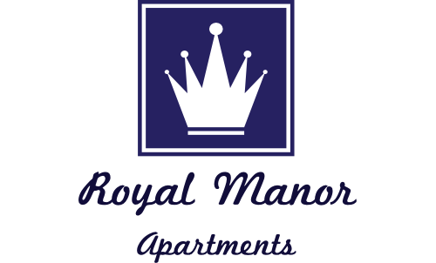
Royal Manor Apartments
8900 Royal Manor Drive
Allison Park, PA 15101
Phone: 412-364-7400
Fax: 412-364-9235 joanne@royalmanorapartments.com
www.royalmanorapartments.com
Phone: 412-364-7400
Fax: 412-364-9235
www.royalmanorapartments.com
Royal Manor Apartments
8900 Royal Manor Drive
Allison Park, PA 15101

Dear Tenant(s),
We are writing to explain our procedures concerning lease expiration. Throughout the next few weeks there are a few things to take note of:
- Now that you have notified us of your intentions to vacate the apartment, we will begin to show it to other perspective tenants. Someone from our office will notify you by telephone the evening before we have to enter the apartment to show it. For this reason, it is important that we have your most current contact number. Please notify us of any new or additional numbers.

- A move out inspection sheet is included with this letter, please take note of everything that needs to be cleaned before moving out. The most common areas that are overlooked include the inside of the cabinets, stove, refrigerator, and medicine cabinet. Carpet cleaning will be deducted from your security deposit; this amount is usually $130 unless the carpets are extremely dirty. Any damages done to the walls in the hallways during move out will be deducted from your security deposit. All trash must be place IN the dumpsters, if you have bulk items you will have to arrange to have them disposed of.

- All keys are due into our office by 9:00am on the last date of the lease_ ____ It is very important that we receive your keys by 9:00am. If you remain in the apartment past this time you will be charged rent for an additional month. When you turn in your keys all the moving and cleaning should have already been completed. If there is no one in the office when you stop by please place them in an envelope, labeled with your name, address, forwarding address and telephone number then drop it in the mail slot.

- Your security deposit settlement will be returned to you via mail within thirty days of the end of your lease. For this reason it is important that you provide us with your forwarding address. Any costs for cleaning or damages will be deducted from your deposit. Any unpaid charges such as rent, lease breaking fee, late charges, etc. will be subtracted from your deposit.

- It is your responsibility to call Duquesne Light 412-393-7100 to have the electric bill turned back to Royal Manor on the last day of your lease.

If you have any questions, please contact us at 412-364-7400.

Thank you,
Royal Manor

ROYAL MANOR APARTMENTS 8900 Royal Manor Drive
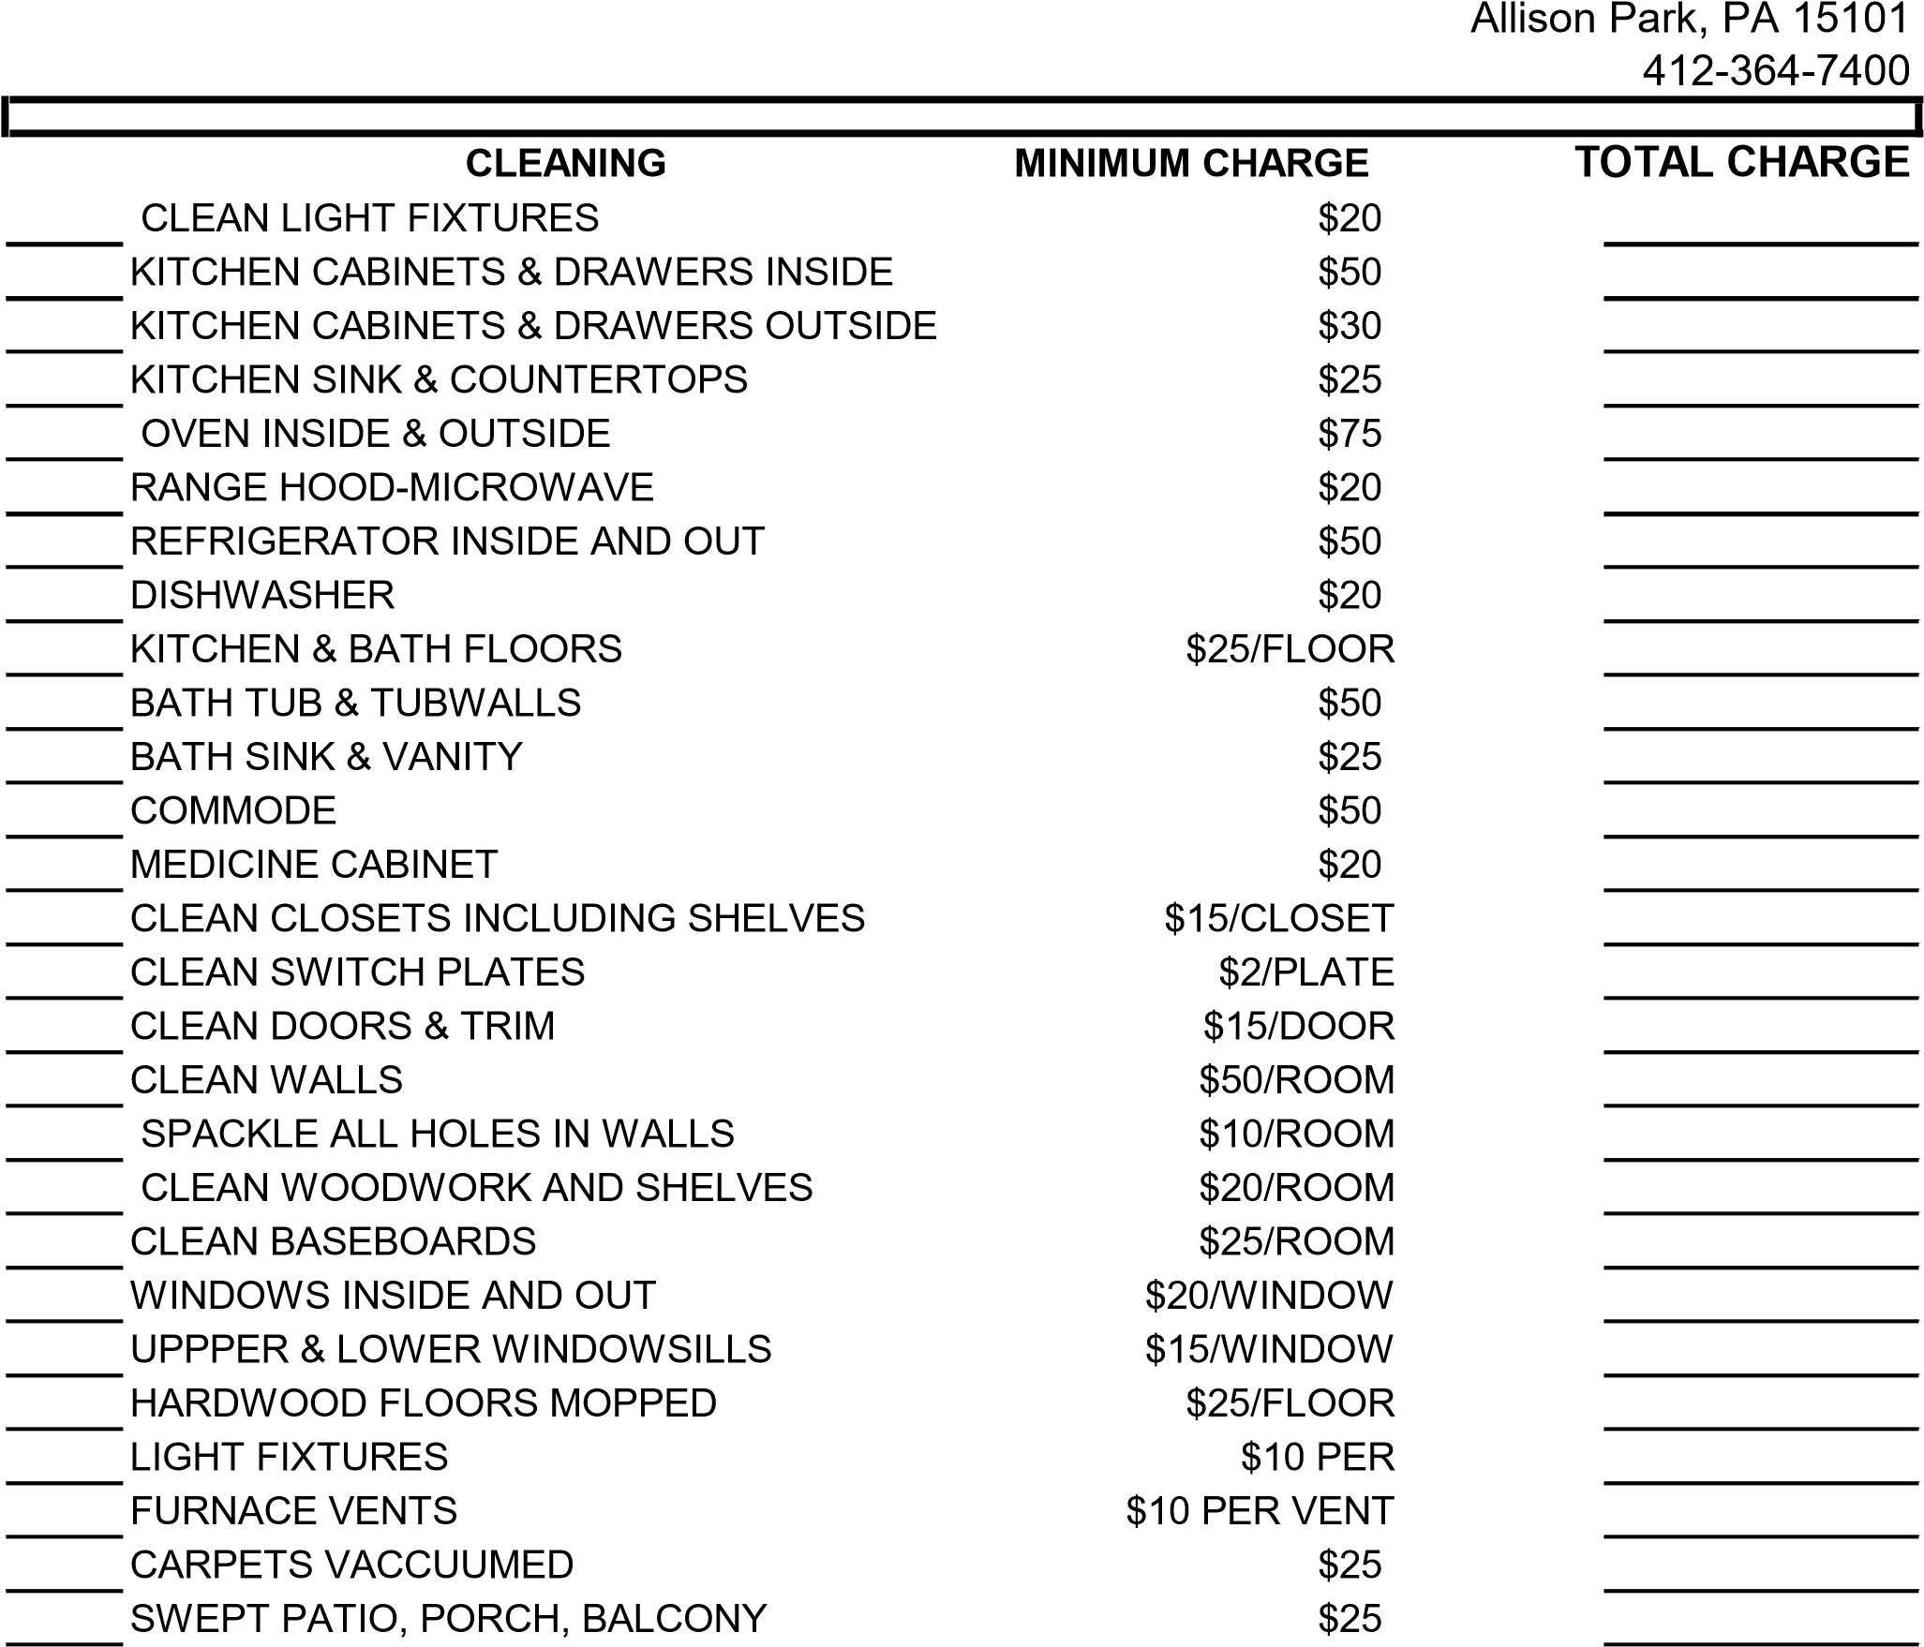
MISCELLANEOUS
HAUL AWAY GARBAGE $50
REMOVE BULK ITEMS $75
LIGHTBULBS IN ALL FIXTURES $3/BULB
BATTERIES IN ALL SMOKE DETECTORS $2/BATTERY
APARTMENT KEY(S) RETURNED $75/KEY
BUILDING KEY(S) RETURNED $100/KEY
MAILBOX KEY(S) RETURNED $50/KEY
LAUNDRY CARD $10
PARKING PASS $20
VISTIOR PARKING PASS $5
OTHER____________________________ VARIES
DAMAGES_________________________ VARIES
____________________________________

*TOTAL CHARGES

